AWS Lambda

### **Serverless-Function as a Service (FaaS)**

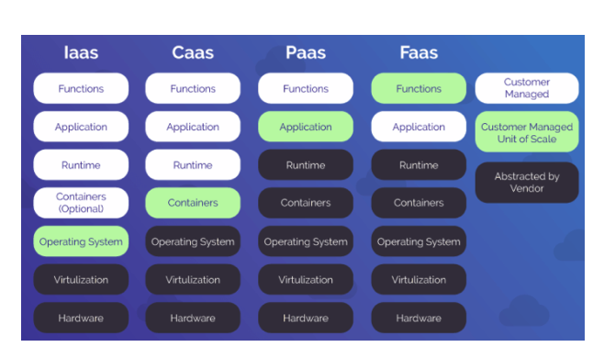

As you remember from the Cloud Computing Basics, there are 3 types of Cloud Service model; IaaS(Infrastructure as a Service), PaaS(Platform as a Service) and SaaS(Software as a Service).

Recently, cloud providers have improved the PaaS service and developed the FaaS service, which allows only customers' code to run as a function. FaaS is also called Serverless.

It is a category of cloud computing services that provides a platform allowing customers to develop, run, and manage application functionalities.

AWS Lambda is the first FaaS offering by a global public cloud provider.

## AWS Lambda

AWS Lambda is a serverless compute service that runs your code in response to events and automatically manages the underlying computing resources for you.

Instead of launching an EC2 instance to run your code on it, you can just deploy your code in Lambda services and you can get the same result. AWS Lambda lets you run code without provisioning or managing servers.

But, what makes lambda valuable is the trigger function. Thanks to the trigger function, Lambda automatically operates the code you deploy in it. After you upload your code to AWS Lambda, you can associate your function with specific AWS resources (e.g. a particular Amazon S3 bucket or Amazon SNS notification). Then, when the resource changes, Lambda will execute your function and manage the computing resources as needed in order to keep up with incoming requests.

In the Lambda service, you will be charged only the functions that you deployed are run. So, you pay only for the compute time you consume. But when you prefer to run your code in EC2 instance you will be charged as long as your instance is running even if your code runs or not.

Lambda also natively supports Java, Go, PowerShell, Node.js, C#, Python, and Ruby code, and provides a Runtime API which allows you to use any additional programming languages to author your functions.

### **How does Lambda work?**

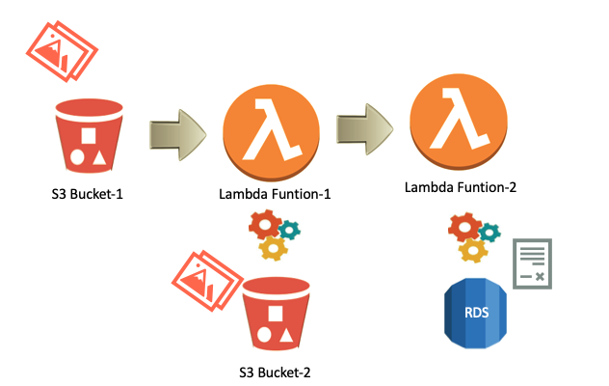

First, the user uploads a file to S3 Bucket-1,

This event causes a trigger for Lambda Function-1.

Then the Lambda-1 function starts to run. This function provides to send a copy of the uploaded file to the S3 Bucket-2

When the copied file sends to S3 Bucket-2 it triggers Lambda Function-2.

Lambda Function-2 starts to run. Lambda Function-2 provides to write the log record to the RDS Database.

As you see, the Lambda function can be triggered by custom events generated by your applications/ devices or another Lambda Function.

But, there is also an API Gateway option we'll see in the following lesson to trigger the Lambda Function.

You are charged based on the number of requests for your functions and the duration, the time it takes for your code to execute.

## API Gateway

## 

API stands for Application Program Interface. Basically, the API defines how device components can communicate with each other.

The API Gateway is responsible for routing, design, and interface transfer requests. All application requests first go through the API gateway. It then sends a message to the correct microservice. The API Gateway can also process a request by invoking several microservices and aggregating the output.

### **API Gateway in AWS**

Amazon API Gateway is an AWS service for creating, publishing, maintaining, monitoring, and securing REST, HTTP, and WebSocket APIs at any scale.

APIs act as the "front door" for applications to access data, business logic, or functionality from your backend services. Using API Gateway, you can create RESTful APIs and WebSocket APIs that enable real-time two-way communication applications.

Amazon API Gateway offers 3 options to create RESTful APIs, HTTP APIs, REST APIs, and WebSocket APIs.

* **HTTP API:** HTTP APIs are optimized for building APIs that proxy to AWS Lambda functions or HTTP backends, making them ideal for serverless workloads. They do not currently offer API management functionality.
* **REST API:** REST APIs offer API proxy functionality and API management features in a single solution. REST APIs offer API management features such as usage plans, API keys, publishing, and monetizing APIs.
* **WebSocket API:** WebSocket APIs maintain a persistent connection between connected clients to enable real-time message communication such as chat apps and streaming dashboards.

### **Lambda and API Gateway**

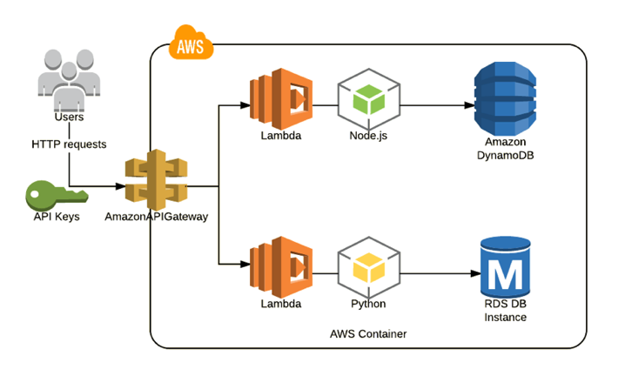

As we mentioned in previous lessons, you can trigger Lambda function in different ways. But the most common usage is to set the API Gateway as a Lambda function trigger. And usually, the Lambda function triggers the other AWS resources as you see into the picture above. So, you are able to create a fully automated environment with Lambda and API Gateway combination.

So, to realize this architecture first, we need to create a Lambda function and then we integrated it to the API Gateway like in the example videos seen below.